**Install Tomcat Web Server**

**Step 1**: Go to Maven's download page at https://tomcat.apache.org/download-90.cgi

**Step 2**: Click on the Binary Distributions **zip** download link and start the download.

**Step 3**: Once the download is finished, go to the downloaded directory and extract the **apache-tomcat-9.0.46.zip** file into a convenient directory of your choice.

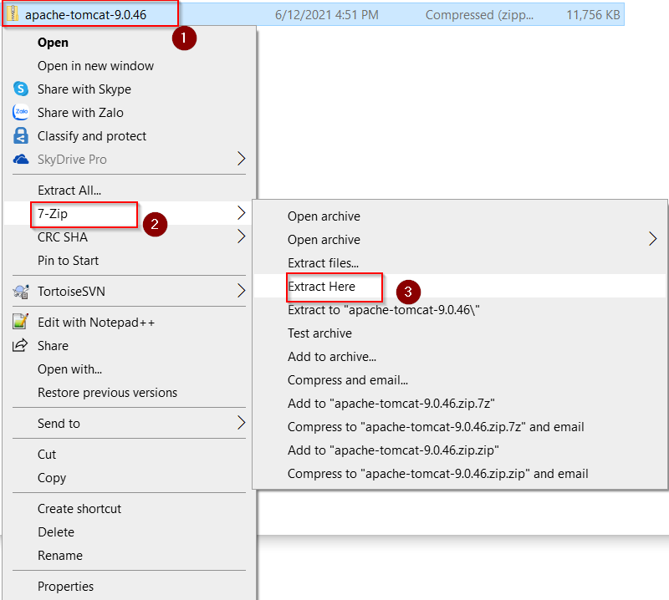

We get the folder: **apache-tomcat-9.0.46**

**Step 4**: Create the folder D:\Dev

This folder stores all development file such as source code, eclipse spring tool suite, tomcat web server …etc

**Step 5**: Copy the folder “**apache-tomcat-9.0.46”** to the folder **D:\Dev**

Note: After install the Tomcat Web Server, we will setting the server for IDE (refer to document: **03. Install and Setting up Eclipse Spring Tool Suite.docx**)